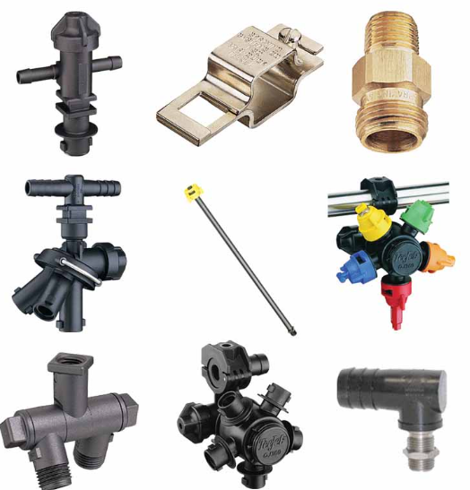
Get Your Sprayer Ready!

10% Off all Sprayer Parts
Until May 31, 2025



